Answer the following questions:

1. Describe the basic components of a typical artificial neuron using a suitable diagram [10 marks]

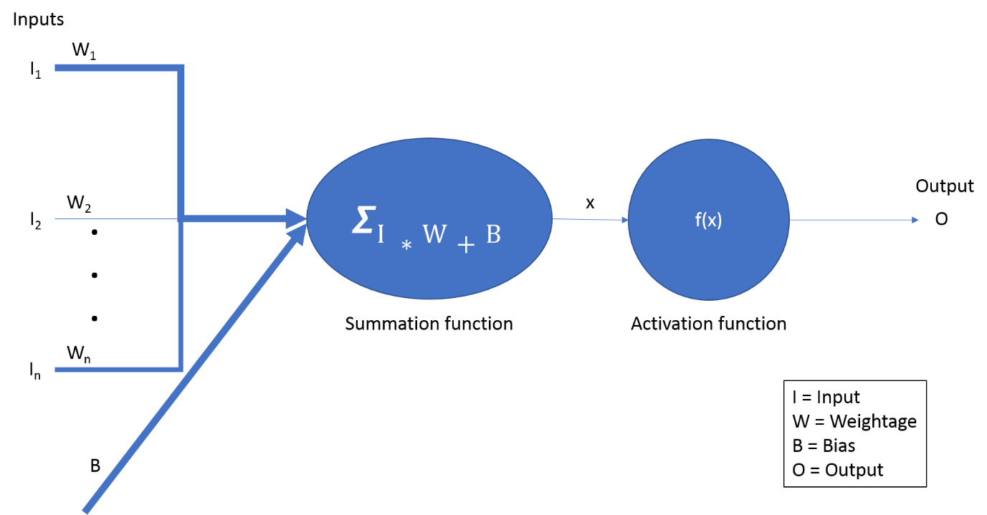

An artificial neuron is comparable to a biological neuron as it is based on the concept of that of biological neuron. An artificial neuron takes in multiple inputs, multiplying with its respective weightage and add with a bias to get a value as the summation of the inputs. Then, that value is passed to the activation function to translate the value into output. For example, if the value is above 0.5, then output = 1. In short, the basic components of an artificial neuron are the input, weightage, bias, summation function, activation function and output.

2. Compare components of a biological neuron with those of an artificial neuron in a tabular format. [10marks]

|  |  |  |
| --- | --- | --- |
| **Traits** | **Biological Neuron** | **Artificial Neuron** |
| Speed | Few milliseconds | Few nanoseconds |
| Size and complexity | Bigger and more complex | Depends on designer, generally simpler and less complex |
| Memory storage | Synapse | Weightage |
| Fault tolerance | Yes | No |
| Control mechanism | Complex, involve hormones and chemical reactions | Simpler, involve mathematical formulae |
| Application | Can do multiple tasks | Highly specialized to do a specific task, Eg. Can be expert in chess, but fail at tic tac toe |